Exercise 4

To fulfill Exercise 4, we chose the domain hotel booking.

We wrote two wrappers: extracting data from **expedia.de** using ***import.io*** and extracting data from **de.hotels.com** using ***Mozenda***.

First we show the process of extracting data:

**Mozenda Agent**

Page: de.hotels.com

Input:

* Place
* Checkin
* Checkout

anzeige.htm

Output: mozenda.xml

Output: tmp.xml

**Import.io Extractor**

Page: expedia.de

Input:

* Place
* Checkin
* Checkout

**Integrate.py**

Query import.io Extractor

Read tmp.xml

* Combine and normalize

Fig 1: Process of wrapping data from two sources. First, the Mozenda Agent runs manually (because the REST API is not available). Then data are exported as XML and stored in mozenda.xml. The python script integrate.py triggers the import.io extractor with provided user input. So links to detail pages are extracted using one import.io extractor, and these links are used with a second extractor to extract detail hotel information as XML. Data from mozenda.xml is read, and data from both sources are normalized and stored in tmp.xml. anzeige.htm reads the file tmp.xml and displays output in a table. If available, images are displayed, if not, just a text is displayed. The color code corresponds to the wrapper source, after moving the mouse over an hotel thumbnail, data extracted from the detail links is displayed.

The output (anzeige.htm) looks as follows:

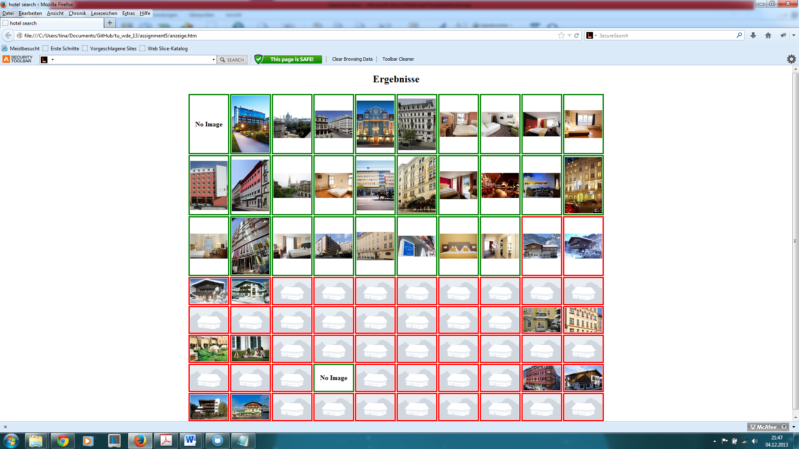

Fig 1: Hotel thumbnails are displayed in a table (if available, otherwise just a text is displayed). A green border corresponds to source mozenda (de.hotels.com), a red border to source import.io (expedia.de).

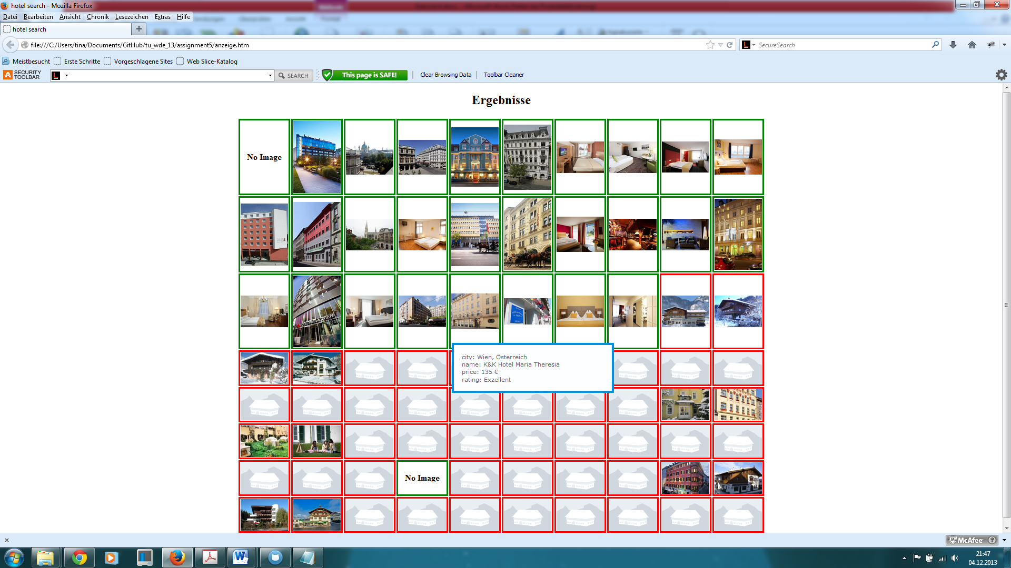

Fig 2: When moving over a hotel thumbnail, information extracted from the detail pages is provided.

Now we provide some information on the used wrappers.

**Import.io** is a completely web-based builder, very fast to learn, but somehow limited. Pagination should work, you can also train it, but after building the wrapper, it is not carried out. After creating the extractor, we query it using a provided python modul.

Here are screenshots from the work with **import.io**:

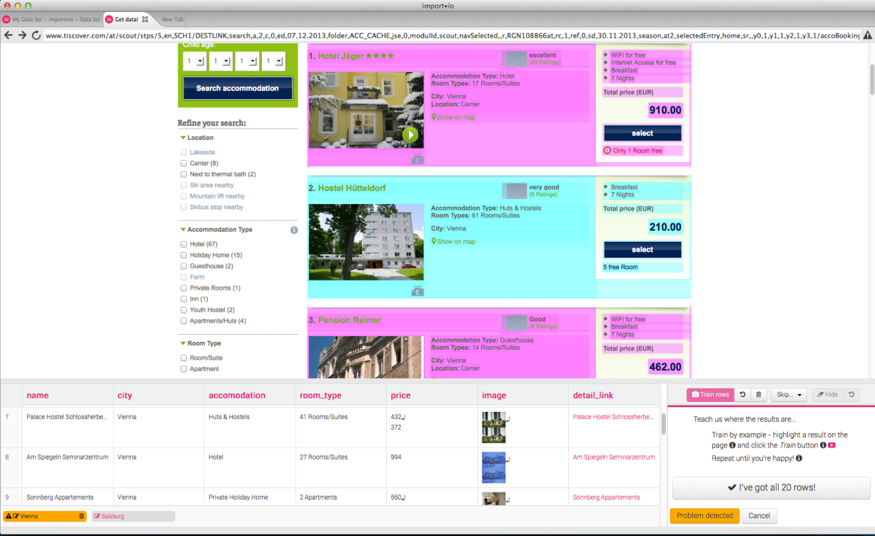

Fig. 4: You always have to choose two to five example objects, so import.io can detect a list of other objects to extract (training the extractor).

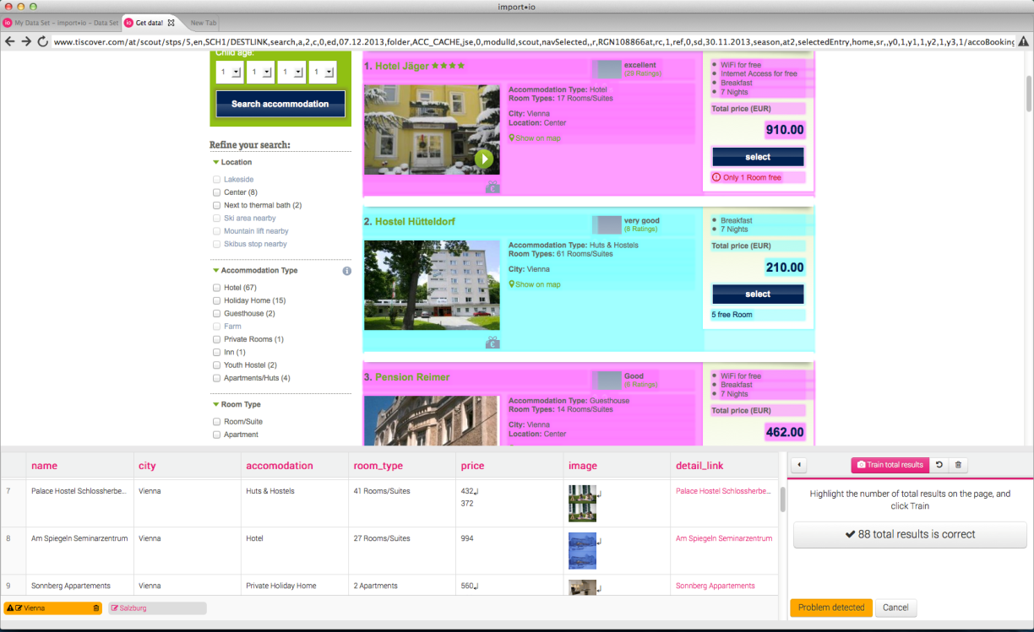

Fig 5: All the captured content is displayed at the bottom for control purpose.

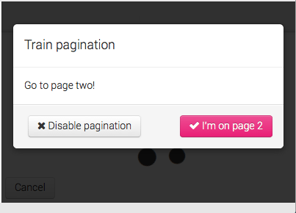

Fig 6: Import.io should be able to train pagination (following next links), but in fact it doesn’t work.

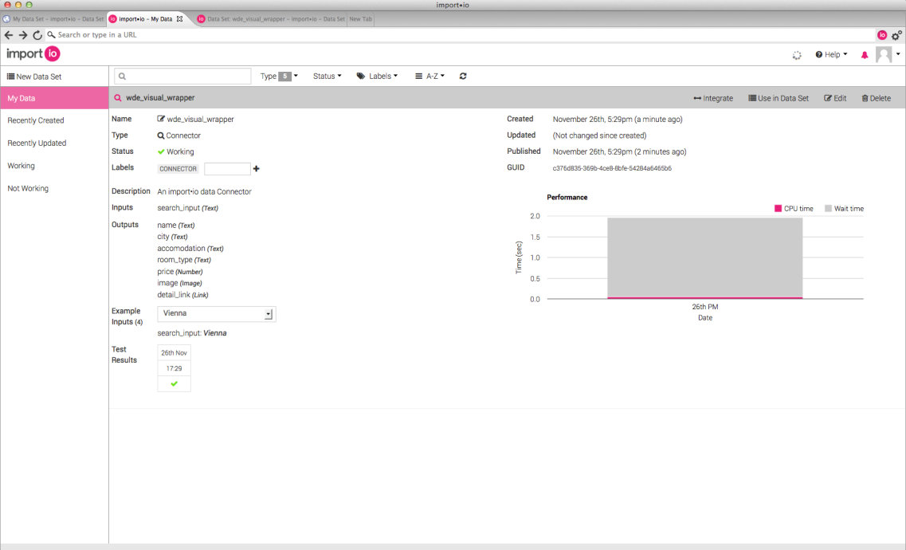

Fig 7: After creating the wrapper, it is stored online and can be queried.

**Mozenda** is a very easy and intuitive tool for creating web extractors. You have to download a software called AgentBuilder, to build and test your agents locally. After creating an extractor, you upload it tot he mozenda server, where it can be run ( you can define schedules and query data using the REST API, but it is not available in the trial version). The agent itself is clearly structured, the actions are shown on the left bottom, jumps to other steps (linke pagination or following detail links) are illustrated by numbers, and details about every action is displayed in the left upper side.

Here are screenshots from working with **Mozenda:**

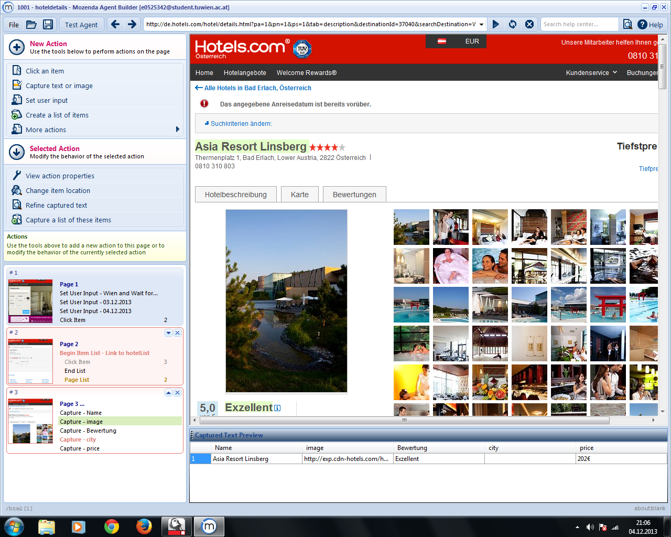

Fig 8: Mozenda is very clearly structured and intuitive; Results are displayed immediately

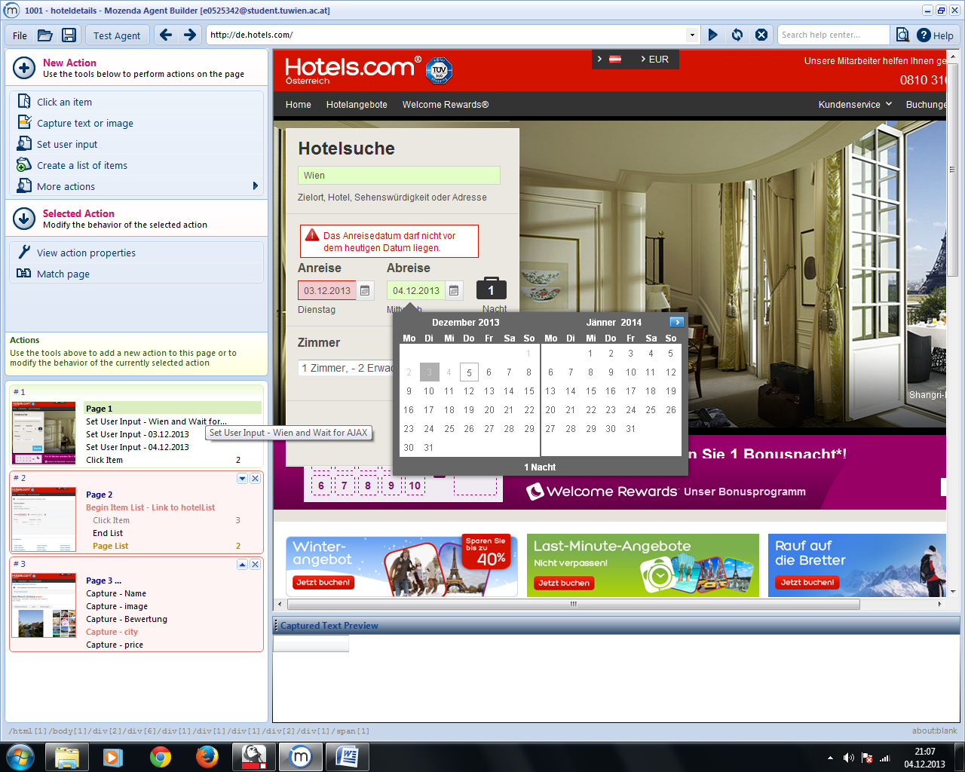

Fig 9: on the left side, you can see the sequence of actions carried out, also the jumps to different steps (like following next or detail links)

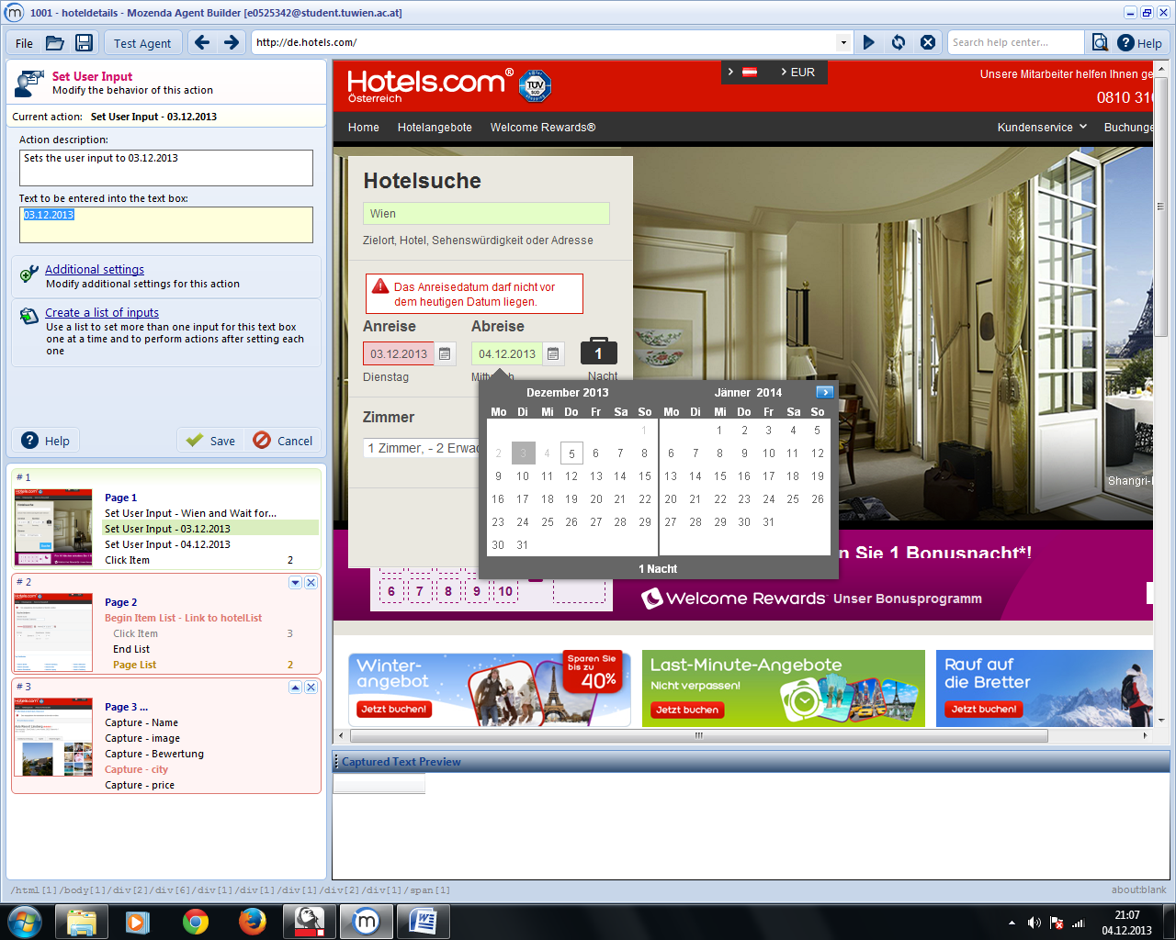

Fig 10: On the left upper site you can define user inputs for input variables

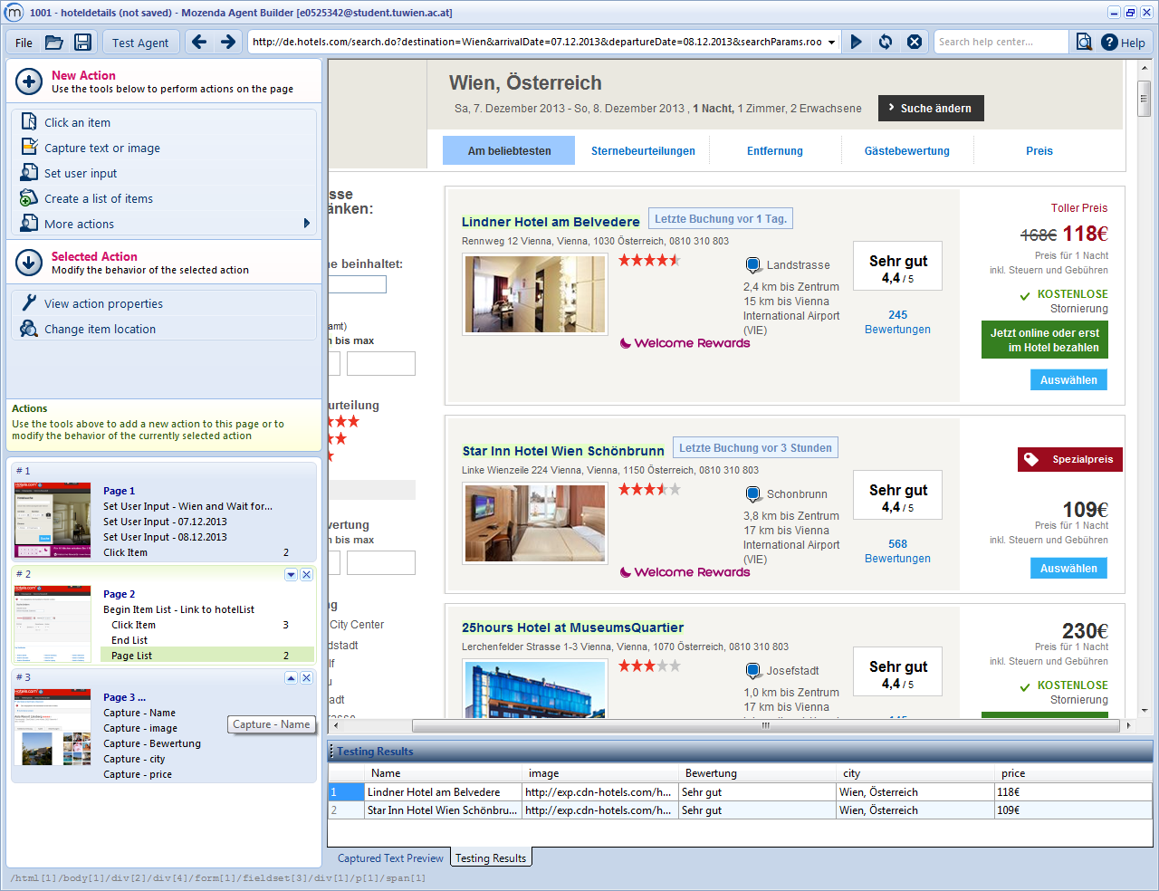

Fig 11: After building the agent, you can test it locally.Results are displayed at the bottom oft he software.

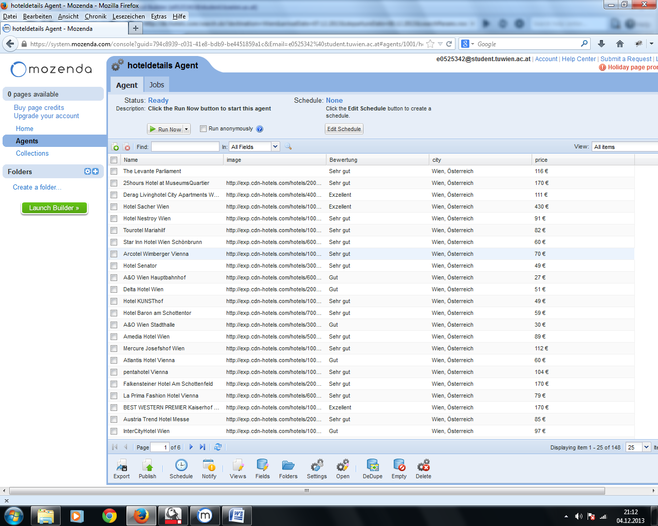

Fig 12: the Mozenda Web Console controls Agents (run, schedule) and Collections (filled by the agent)

Now we answer **additional questions:**

* Document Model (DOM, Text, anything in addition to these)

* Form Filling and Macro Recording

Quite natural I think. You navigate to the connector and can then start to record

the form filling. Having seen the Lixto Visual Developer this is very restricted

and there not much to configure.

* Transform original tree structure

* Natural Language Processing Support

* Heuristics and Rule Generation

Sometimes the recognistion of some rules does not work very well with only a few examples.

It sometimes takes put to 5 examples until the recognition of the attribute is learned.

But as far as I have worked with import.io it is very robust after it is correct.

* Image Recognition

Images are handled quite nice. When selecting them as a attribute of the output they

are displayed directly.

* Scripting

While the rule learning is in progress there is not many parameters you can tweak.

But when the rules are completed you can access a very rich API in alot of different

languages to aquire the data.

* Ajax Support and DOM Freezing, DOM Event Support

At first it always tries not to use the javascript engine. There are alot of dialogs

asking you "Does the site look as expected?". If not it is reloaded with javascript enabled.

This I think is quite good idea in terms of resources.

* Input and Output Formats

Rich set of outputs. The wrapped data can be downloaded as EXCEL,HTML,JSON or CSV and

by exposing a REST API those can be processed by any programming language.

* Control Browser Settings like User Agent

* Parameterization

Can be specified when the is fetched from the REST API. This is quite conveinient.

* Iteration, Conditions, Loops

* Robustness and Adaptation

* Automated Steps, Machine Learning (from multiple examples)

* Storing screenshots / html source to file system

I don't think this is implemented in import.io.

* Performance and Scalability

Decent. Compared to open dapper it is a little faster.

* Ease of Use

* Proxy Variations

* Captcha Support

I don't think there is captcha support.

* Execution Environment